**Chapter 3: Architecture and Design**

**High Level Architecture of Project**

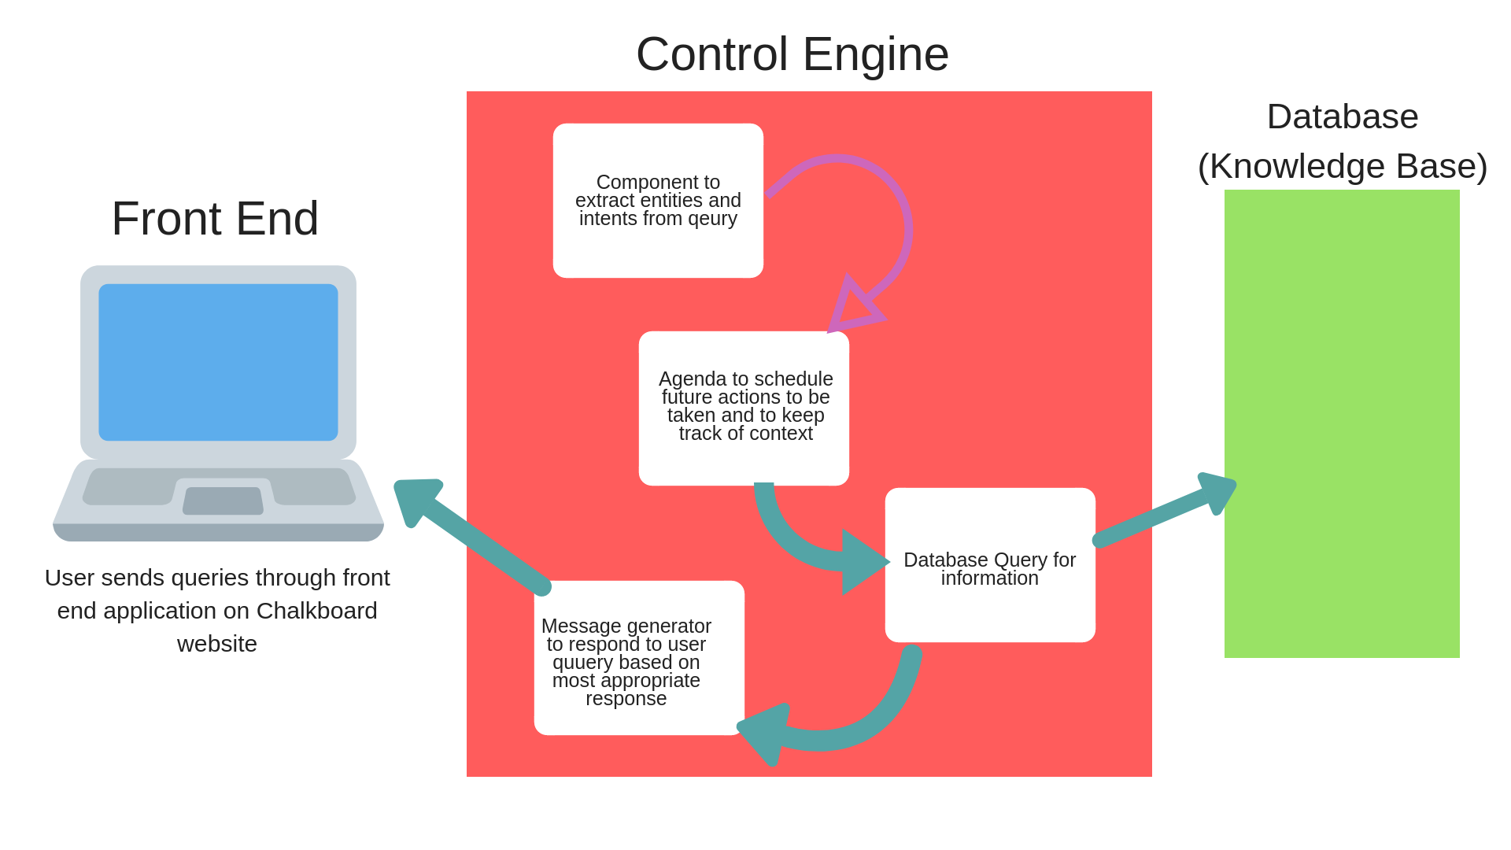

**Key Modules in the Architecture/Design**

**Front end web application**

Chalkboard Education already have a website built using HTML, CSS and JavaSCript. I will create an applet to run on the website to serve as the front-end that users would use to query the database for information. Like the original website, this front end would be built using HTML, CSS and JavaScript. The users query would be passed from the text box to the control engine which would then classify the issue and query the database for a response and return a response to the user.

**Database (Knowledge Base)**

This would serve as the knowledge source from which the dialog system would

* Classify user queries
* Determine appropriate responses
* Generate responses too be returned to user

The database would be a collection of formatted text files with sourced from past user queries and frequently asked questions in the past. They would also feature multiple documents to help the chatbot with classification. Also in the database would be question-answer pairs for queries that have more straightforward responses that do not require more complex logic and decision making on the part of the control engine. Since there exists a very limited scope of problems users might have pertaining to the use of Chalkboard’s platform, the database would of a small size. This gives room for adding datasets that would enable the dialog system have ‘small talk’ conversations with users as a means to increase the user experience of the application.

**Control Engine**

Since the dialog system has multiple knowledge based on which to evaluate queries, there needs to be some engine that decides what task to perform next. The engine would create an agenda, which would store potential processes to be undertaken based on user queries. It would examine the agenda, decide what needs to be done next and perform the function. The engine would also be responsible for maintaining context throughout the interaction with the user such that information from earlier in the conversation could be made available at a later stage. This would be necessary for maintaining flow in the conversation. The control engine includes a mechanism for extracting intents and entities from user queries and a message generator responses based on feedback from the database.